**FLOODS AND MOTHER NATURE**

**-Vigya Kaul, BVCOE**

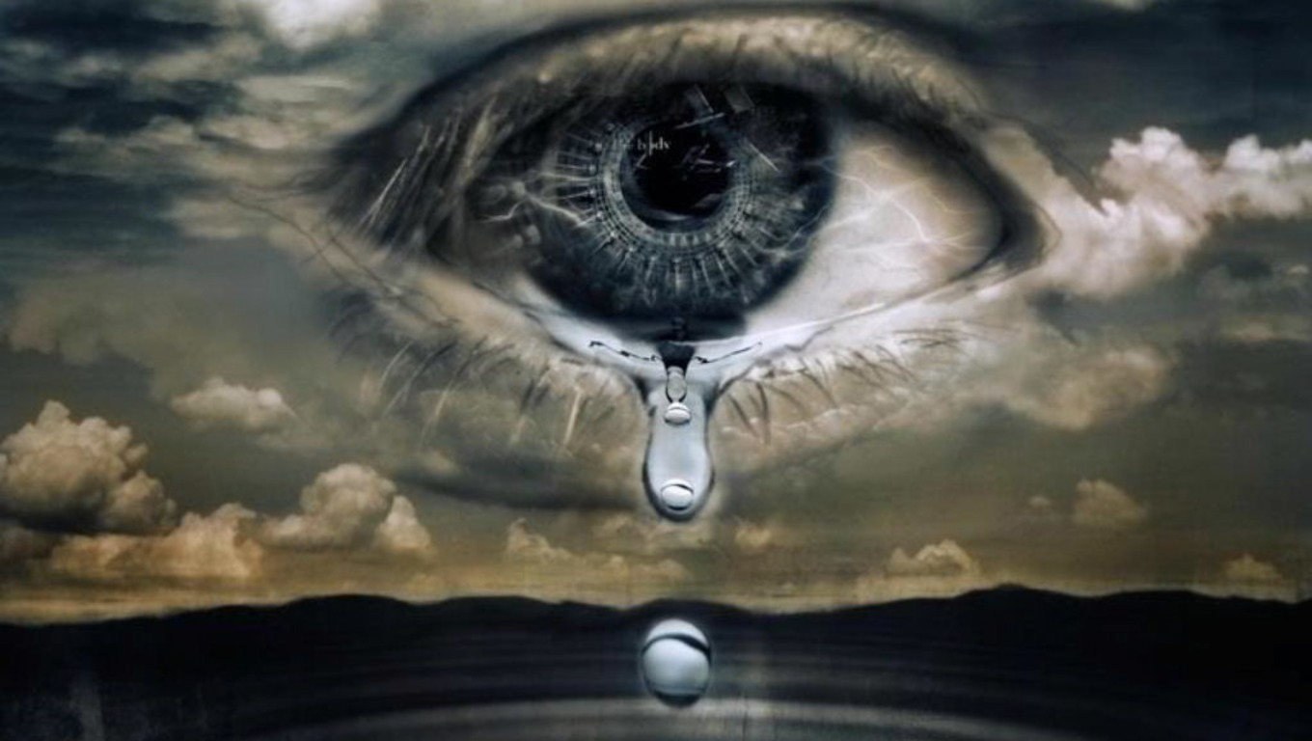

When the morning awakes, to the dark night it waves.  
My feelings persuade me to again perambulate.  
To feel the Sun, the Breeze, as they come my way.  
But look oh unfortunate! This world takes it all away.  
The gay that fades when it says, “A lot is to be done, mend your ways.”  
Materialism that takes it all over, the craving for money makes them hover.  
Indifferent! Pityingly, I glance and move on to the beats,  
Towards the world of insane freaks!

Think about the Floods that occur due to deforestation, caused by the greed of humans.  
Could these floods be a warning to us? Revenge, may be?  
Warning about the degradation of the Nature's condition, big time! In the future!  
A Revenge for the misdeeds done with the Nature!   
"Tit For Tat" more appropriately.

Floods cause deprivation of humanity but do you; anyhow feel that "A Mother" could hurt her children even if the children do not treat her right? If yes, then I am sorry to say that she should not be called A Mother!

A Mother is symbolic of a figure that is patient, loving and caring, and here by loving and caring I do not mean being conscious about her child's success or prohibiting its freedom for the sake of so called protection or scolding the child when it scores low or does not listen to her. The love of a Mother is intense, deep and most importantly, sacrificial. It cares about the needs of the child. It respects its feelings. It is never boastful. It accepts the situations of parting with the child, obviously with a sweet pain. It trusts! In short, it is the most blissful feeling! "MAMTA"- Motherly Affection!

We have turned Mother Nature so weak that she is unable to protect us from the disasters. Still such is the power of her love that it withstands the great sufferings and pain and saves the world from the destruction. It is like Jesus being crucified for the sins committed by his children!

